Convalescent plasma donor recruitment
Regional social media assets

SOCIAL TILE | SUGGESTED CAPTION
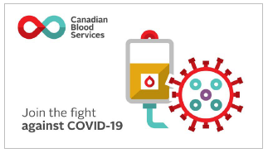 | If you are a COVID-19 survivor, you could potentially help others with the virus by convalescent donating plasma.  Learn more and sign up to donate at blood.ca/convalescentplasma
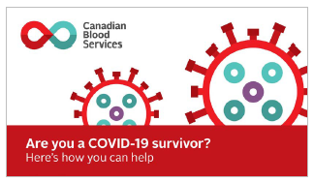 | Donated plasma from survivors of COVID-19 could be the key ingredient to help others with the virus.  If you meet the convalescent plasma donor requirements, please join our registry of potential donors.  Learn more and sign up to donate at blood.ca/convalescentplasma
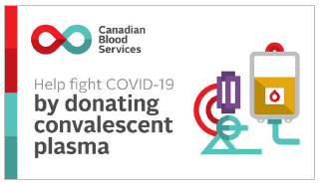 | If you are a #COVID19 survivor, you could potentially help others with the virus by donating convalescent plasma.  Learn more and sign up to donate at blood.ca/convalescentplasma
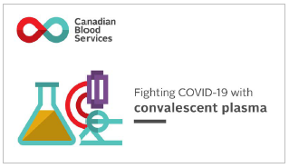 | If you, or someone you know, have fully recovered from COVID-19, you may be able to help others with the virus.  Convalescent plasma is collected from someone who has recovered from a virus. When a person is infected with a virus, their body starts making antibodies to fight it. These antibodies could be the key ingredient for a treatment to help others with the same virus.  Learn more at blood.ca/convalescentplasma
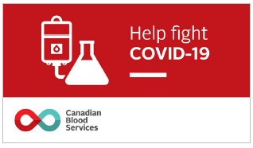 | Convalescent plasma could be the key ingredient to help others recover from COVID-19.  If you, or someone you know, have fully recovered from COVID-19, you may be able to help others with the virus by donating convalscent plasma.  Learn more and sign up to donate at blood.ca/convalescentplasma

